**COMSATS University Islamabad,   
Abbottabad Campus**

**Project Proposal   
(SCOPE DOCUMENT)**

**for**

**Video Surveillance System**  
Version 1.0

***By***

**Zain Asif CIIT/FA20-BSE-136/ATD**

**Nabeel Saleem CIIT/FA20-BSE-122/ATD**

**Hammad Ur Rehman CIIT/FA20-BSE-126/ATD**

***Supervisor*Dr . Saad Mustafa**

***Bachelor of Science in Software Engineering (2020-2024)***

|  |  |  |
| --- | --- | --- |
| **No.** | **Comment** | **Action** |
|  |  |  |
|  |  |  |
|  |  |  |
|  |  |  |
|  |  |  |
|  |  |  |

**SCOPE DOCUMENT REVSION HISTORY**

**Supervisor Signature**

**Date:**

**Table of Contents**

**1.** **Introduction 4**

**2.** **Problem Statement 5**

**3.** **Problem Solution for Proposed System 5**

**4.** **Related System Analysis/Literature Review 5**

**5.** **Advantages/Benefits of Proposed System 5**

**6.** **Scope 6**

**7.** **Modules 6**

7.1 Module 1: Registration and Authentication 6

7.2 Module 2: Video Frame Extraction 6

7.3 Module 3: Upload Video 6

7.4 Module 4: Notification………………………………………………………………………………..6

7.5 Module 5:Action Detection…………………………………………………………………………6

7.6 Module 6 **:**Video Saving and Retrieval 6

**8.** **System Limitations/Constraints 6**

**9.** **Software Process Methodology 6**

**10.** **Tools and Technologies 7**

**11.** **Project Stakeholders and Roles 7**

**12.** **Team Members Individual Tasks/Work Division 8**

**13.** **Data Gathering Approach 8**

**14.** **Concepts 8**

**15.** **Gantt chart 9**

**16.** **Mockups 10**

**17.** **Conclusion 11**

**18.** **References 11**

**19.** **Plaragism Report 11**

**Project Category: (**Select all the major domains of proposed project**)**

* **A-**Desktop Application/Information System **B-**Web Application/Web Application based Information System **C-** Problem Solving and Artificial Intelligence ** D-**Simulation and Modelling ** E-** Smartphone Application ** F-** Smartphone Game ** G-** Networks ** H-** Image Processing****Other (specify category) ______________________

# **Abstract**

We are developing a AI system which ensures the safety of people by detecting the voilance or suspicious activity. It divides the video in chunks and the feed them into vision transformer model which is trained on our dataset . Then our model process the video and provide results of video if it is related to the classes of voilance and suspicious activities present in our dataset and notify to authorized users.

# **Introduction**

This project proposal emphasizes the urgent requirement to tackle the increasing crime rates in Pakistan, which present a major danger to public safety. Crime cases are going up, which demands proactive actions to ensure security and save lives of people. At the moment, instances of violence are mainly seen through CCTV camera recordings; however, this data often reaches the authorities only after the incident has happened,. In response to this challenge, we suggest creating a real-time violence detection System.

The aim of this System is to quickly detect violent activities as they happen,and inform the admin or security officials registerd through admin access. The objective is to speed up the process, ultimately resulting in catching wrongdoers and saving lives and maintanig security.As not everyone can afford to hire a dedicated security person to continuously monitor live camera feeds due to the high associated costs. Furthermore, even with human surveillance, keeping constant watch on a computer screen all day is not practical.

Thus, the suggested solution proposes an intelligent software system ,that automatically detects potential threats and informs the registerd users without needing constant human oversight. This approach provides a more cost-effective and efficient way to strengthen security, reduce response times, and ultimately create a safer environment for the community

# 

# **Problem Statement**

The manual monitering systems faces a critical challenge in effectively identifying and responding to violence and suspicious activities in real-time. Humans can be fatigued and easily distracted when monitoring video feeds for extended periods. This can result in missed events or delayed reactions to suspicious activities. Employing human security personnel 24/7 is expensive, and the cost increases with the need for multiple shifts

# **Problem Solution for Proposed System**

To address the limitations of manual monitoring systems in identifying and responding to violence and suspicious activities in real-time, we propose the development and implementation of an intelligent and cost-effective video surveillance system. Our system basically makes the chunks of videos and then pass to AI model this model will identify any suspicious and violence activities. Once activity is detected it notifies the authorized users, who can than take action accordingly by informing responsible authorities if needed.Also users can upload videos to detect voilance in specific short footage.

# 

# **Related System Analysis/Literature Review**

|  |  |  |
| --- | --- | --- |
| **Application Name** | **Weakness** | **Proposed Project Solution** |
| Efficient Violence Detection in Surveillance | Efficient Violence Detection in Surveillance uses LSTM model which is more complicated than traditional RNNs and require more training data in order to learn effectively  . | Our system will use ViT model which excels in processing spatial and temporal information in videos. |
| The Lahore Safe City Project | The main objective of the Safe City project is to develop the security and surveillance system in the city on modern lines, for which 10 thousand new CCTV cameras will be installed at important places in the city But this system is only for monitoring purposes not for violence detection | The primary purpose of our Violence Detection System is to detect violence activities. |

# **Advantages/Benefits of Proposed System**

**Preventive Measures:** Early detection of violent incidents allows for quick intervention and preventive measures, potentially saving lives and reducing harm.

**Enhanced Security:** Increases security in public spaces, workplaces, and other environments, making them safer for all individuals.

**Rapid Response:** Alerts authorities and security personnel immediately, enabling faster response times to incidents.

**Scalability:**Can be implemented in various settings, such as schools, public transportation, and residential areas, to cater to different security needs.

**Cost Savings:** Reduces the need for constant human surveillance, potentially leading to cost savings for businesses and institutions.

**User-Friendly:** Offers an intuitive interface for users to review and verify incident

**Scope**

The proposed project aims to develop a video surveillance application with violence detection. The primary focus of this project is to create system capable of identifying violent incidents as they occur in video. To create a successful video surveillance application, it's important to understand the scope of the project, including what to do and what not to do

.Our application should do**,** Admin should login and Sign up. Only Admin will authorize people to have access.Only registered users will see the abnormal activity detection in application..System should detect violent incidents.User should Receive an alert Notification when there is some violent incident detected.Our System extract the violence portion and user can see the clip on their devices.User can also upload video to detect voilance in it.

Our application cannot do.Our AI model could not always accurately detect violence.Our AI model could not detect correctly footage having low light.Our AI model could not Detect every abnormal event in the environment. Performance could vary based on the quality and positioning of camera.Changes in weather conditions or cluttered backgrounds could affect the accuracy of the AI model.Delay can occur due to sending every frame to AI model for processing violence detection.

# **Modules**

Module 1: Registration and Authentication: Registration and authentication is a critical component of the video surveillance system, ensuring that only authorized personnel can access the application. This module will allow admin Login in the application,update credentials and register users,delete users.It will ensure authorized access to the application.

Module 2: Upload Video: In this module user can upload a recorded video from gallery to detect if there is any voilant activity in it.

Module 3: Notification: In this Module when a violent incident is detected, the system will trigger an alert notification to the users.

**Module 4: Action Detection:** Frames are devided into patches. Patches are embedded for computer understanding and are flattened.Now it is treated as token and positional embedding is applied to tell computer which patch belongs to which part of video.Vit utilizes transformer layers to capture interactions and dependies among tokens in a self attention mechanism.And is classified using fully connected layers

**Module:5:Video Saving and Retrieval:** Voilance detected portions of video are saved in databased and showed to users.

**Module:6:Video Frame Extraction:** Extract frames from video and feed it to model for analysis.

# 

# **System Limitations/Constraints**

* We will develop an android based application only.
* Internet Connection is mandatory

# **Software Process Methodology**

* Iterative

In this application we will use Object oriented approach

Choice of methodologies will not affect tools and technologies because the approach we are using follows the object oriented methodology

Choice of methodology will affect the nature of design by making it more flexible and scalable.

# **Tools and Technologies**

|  |  |  |  |
| --- | --- | --- | --- |
| **Tools**  **And**  **Technologies** | **Tools** | **Version** | **Rationale** |
| Android Studio | 2022 | IDE |
| Flutter SDK | 2023 | UI toolkit |
| Firebase | CSC 6 | Realtime DBMS |
| Star UML | 3.2.2 | System Modeling |
| MS Word | 2022 | Documentation |
| MS Power Point | 2022 | Presentation |
| Figma | 2.0.5 | Mockups Creation |
| **Technology** | **Version** | **Rationale** |
| Dart | 6.0 | Programming language |
| Django | 4.2.5 | Backend Development |
| Flutter | 3.10 | Mobile Application Development |
| UML | 2013 | Modeling Language |

# 

# **Project Stakeholders and Roles**

|  |  |
| --- | --- |
| **Project Sponsor** | COMSATS University Islamabad Abbottabad Campus |
| **Stakeholder** | Mention your stake holders with their roles and responsibilities.  Default option will be:   * **Zain Asif (FA20-BSE-136)** * **Nabeel Saleem (FA20-BSE-122)** * **Hammad ur Rehman(FA20-BSE-126)** * Project Supervisor Name:   **Dr . Saad Mustafa**   * Final Year Project Committee: Evaluation of project |

**Team Members Individual Tasks/Work Division**

**Table 4Team Member Work Division for Proposed Project**

|  |  |  |
| --- | --- | --- |
| **Student Name** | **Student Registration Number** | **Responsibility/ Modules** |
| Zain Asif | FA20-BSE-136 | * Documentation * Design * Implementation |
| Nabeel Saleem | FA20-BSE-122 | * Documentation * Design * Implementation |
| Hammad Ur Rehman | FA20-BSE-126 | * Documentation * Design * Implementation |

# 

# **Data Gathering Approach**

* Introspection
* Group Discussion
* Brainstorming
* Interviews of students of different departments.

# **Concepts**

**Concept-1:** API Integration: As we will develop API for our application we will learn API integration.

**Concept-2:**Firebase Database: In this project we’ll learn how to use firebase database and how to authenticate, register users, store, and get data from firebase in real time environment.

**Concept-3:** Vision Transformer Model:We will learn and understand the architecture of vision transformer model

**Concept-4:** Abnormal Activity detection in video:As we will train our model on the different classes of abnormal activities so we will learn to detect it.

**Concept-5:** **Machine Learning :** To learn and understand the Machine learning models .

**Concept-6:** **Programming Language:** We Will learn python for machine lerarning models ,dart for android development and Python for backend Development

# **Gantt chart**

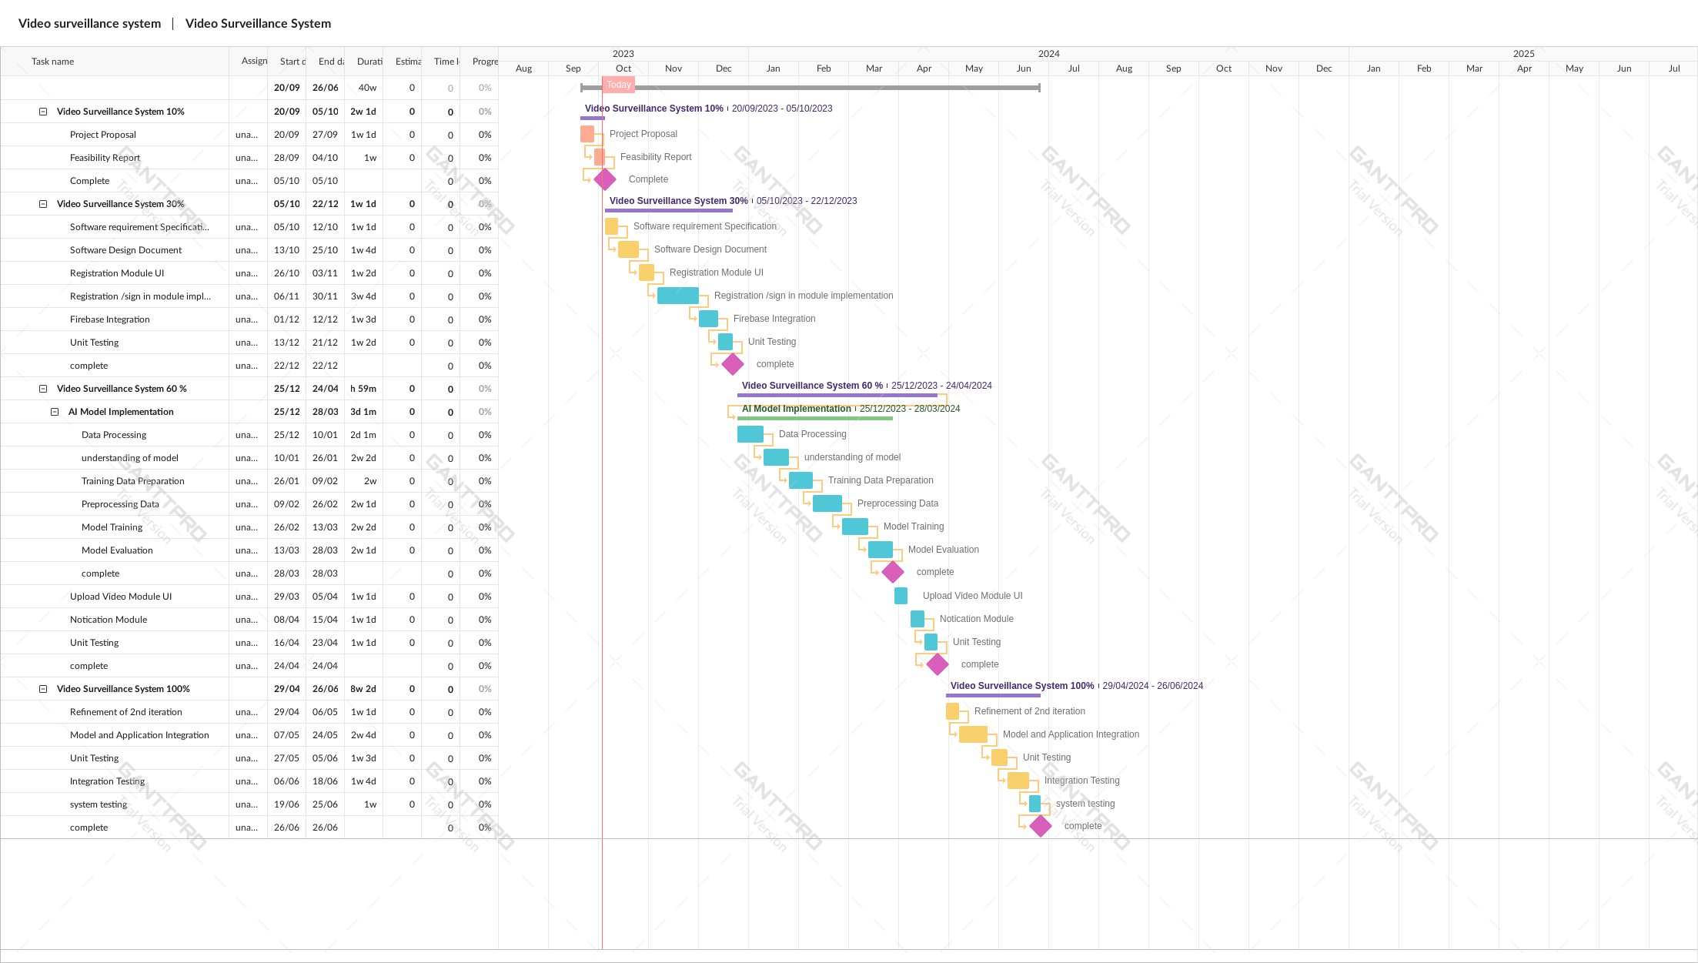

# **Mockup**

Notification Mockup Videos Clips Mockups



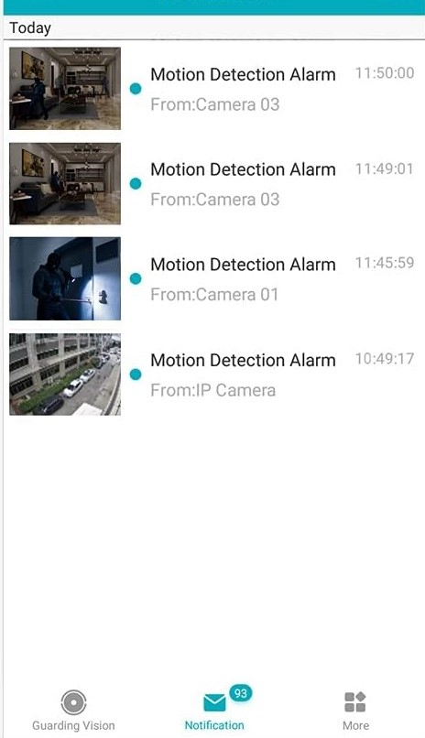

Accounts Mockup

# **Conclusion**

A video surveillance system is a critical tool for enhancing security and ensuring public safety. By continuously monitoring areas in real-time and leveraging advanced technologies like machine learning, it helps identify potential threats, detect suspicious activities, and enable swift responses to incidents. This proactive approach not only deters criminal behavior but also provides valuable evidence for investigations. A well-implemented surveillance system, when integrated with appropriate user management and incremental development, can contribute significantly to creating safer communities.

# **References**

Mention the books, research papers, web links etc.

# **Plagiarism Report**

Attach the Plagiarism report of your project scope document from library staff of turnitin tool (http://turnitin.com